Appendix to “Product Innovation, Product Diversification, and Firm Growth: Evidence from Japan’s Early Industrialization

(will be posted online once the paper is published)

Serguey Braguinsky, Atsushi Ohyama, Tetsuji Okazaki, Chad Syverson

January 2020

A.1 Data construction
A.1.1. Product varieties data
Our data source for firm-level output by product varieties comes from bulletins (“Geppo”) published by the All-Japan Cotton Spinners’ Association (“Boren,” using its name’s abbreviation in Japanese). These bulletins were issued monthly, starting from 1889 (even earlier data are available from government statistics, starting from 1883), and they, in particular, contained firm-level input and output data for all members of the Association which was basically the universe of all firms operating in the industry at any time. The first time the breakdown of output by product varieties was added to the bulletins was May 1893. Since then, the data have been published continuously in dedicated tables in each issue. We have coded all such tables until December 1914 which is the end of our sample. Photo 1 presents a table showing output by product varieties by each firm for December 1906.

Photo 1. Output by product varieties table, December 1906.

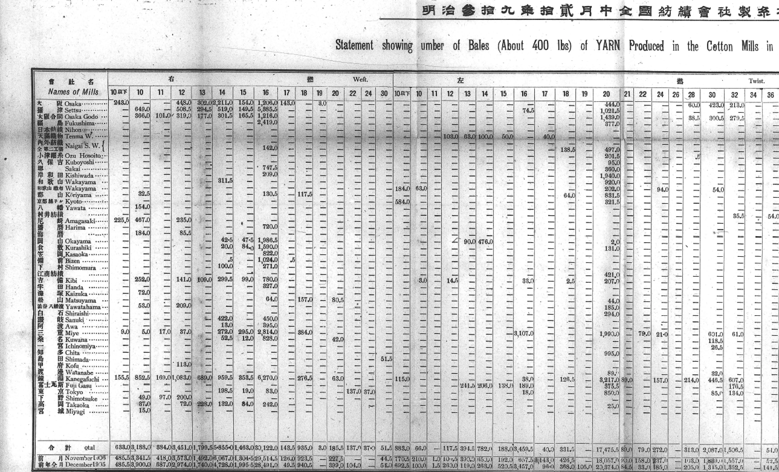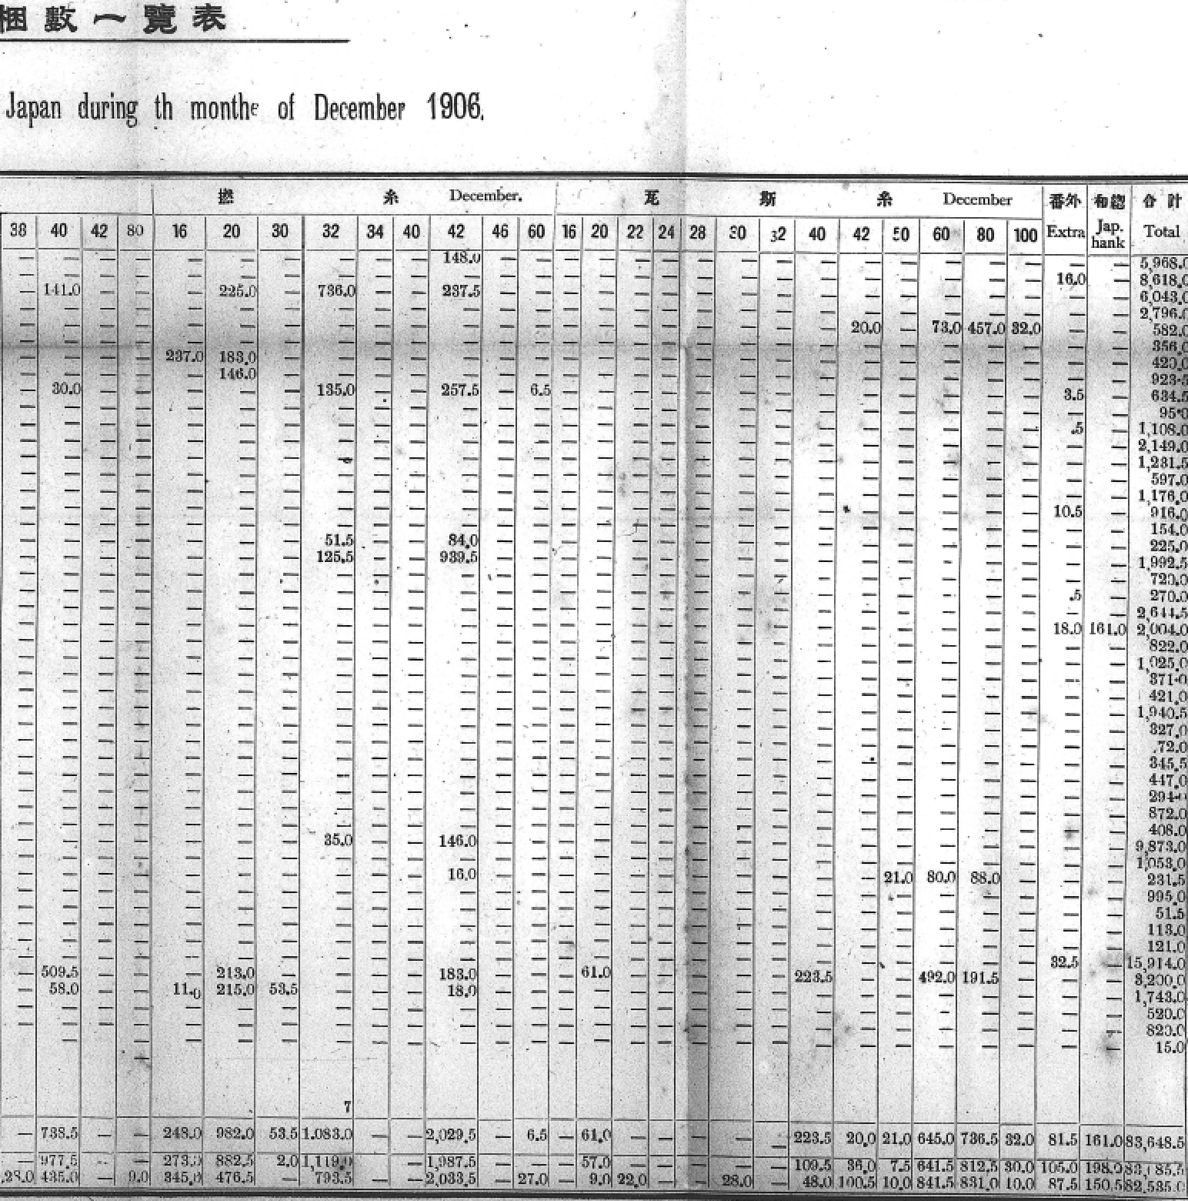
Source: Geppo, No. 173, Jan. 25, 1907.

A.1.2. Engineers data
The information about university-educated engineers was obtained from restricted-use alumni lists, Gakushikai Kaiinroku compiled by Gakushikai (The University Graduates’ Society), the association of the alumni of Imperial Universities, containing information about addresses and workplaces of the graduates. Until 1897 Tokyo Imperial University was the only one. In 1897 Kyoto Imperial University was founded and its first cohort graduated in 1901. Two more Imperial Universities were founded in 1907 and 1911 but there were no graduates of the last one available to the industry at the end of our sample (1914) as yet.
The above information was verified and supplemented, especially for earlier years, from chapters dedicated to the history of each firm in Kinugawa (1964) and from published company histories (Kanebo, 1988; Unitika, 1989; Toyobo, 1986; Fujibo, 1998, Shikibo, 1968, Kurabo, 1953). Engineers educated in British universities, in particular, were identified from these industry history sources and added to the list of graduates of Japanese Imperial Universities.
For technical college graduates, we used annual Ichiran (Catalogs) (Tokyo Koto Kogyo Gakko Ichiran, Kyoto Koto Kogei Gakko Ichiran, Osaka Koto Kogyo Gakko Ichiran, Nagoya Koto Kogyo Gakko Ichiran, Kumamoto Koto Kogyo Gakko Ichiran, and Sendai Koto Kogyo Gakko Ichiran), which contain the lists of alumni with their current workplaces, and picked up all graduates of mechanical engineering and dyeing departments who worked in one of the firms in our sample in any given year. The first technical college was established in Tokyo in 1881, the second one in Osaka, in 1896. By the end of our sample there was the total of six technical colleges that already had alumni working in the industry; all those alumni data were coded and added to the database of educated engineers employed by cotton spinning firms.

A.1.3. Board members and merchants data
About 90 percent of firms in our sample (and all significant firms) were public (joint stock) companies, obligated to issue shareholders’ reports every half a year (see Braguinsky et al., 2015, and Agarwal et al., 2019, for details). We have photocopied and processed 1,443 reports on 106 firms (Kokajo, 1883-1914), all such reports that we could find surviving until the present day. Each report, in particular, contains a list of all shareholders and board members (“torishimariyaku”) of the company issuing it. For privately held firms as well as in cases where some shareholders reports of incorporated firms were missing in the archival data, we supplemented this with information from the All-Japan Registry of Firms Executives (“Yakuinroku”), the first issue of which was published in 1893. We coded and reconciled the information on the members of the boards across these two sources, and also cross-checked the data by using information in company histories (Kinugawa, 1964; Kanebo, 1988; Unitika, 1989; Toyobo, 1986; Fujibo, 1998, Shikibo, 1968, Kurabo, 1953), and in Geppo.
The data published in “Yakuinroku” (above) were used to extract the names and addresses of board members of the four incorporated cotton yarn-related trade companies (Naigai Wata, Nihon Menka, Nitto Menshi and Mitsui Bussan), while the data contained in the 1943 brief history of Osaka Three Article Exchange (“Sampin Shoshi”) were used to extract the names of board members and traders registered at this most important exchange dealing with cotton and cotton yarn in each year. The data in four available editions of Nihon Zenkoku Shoko Jinmeiroku, a nationwide registry of traders and manufacturers (for 1892, 1898, 1907, and 1914), were utilized to extract the names and addresses of individual merchants likely to play the most prominent role in cotton spinners’ output markets; that is, traders in cotton yarn and cotton yarn-woven garments who paid business taxes exceeding a certain threshold (10-15 yen, depending on the year). We considered all these individuals to be potential providers of market knowledge (“market ties”) for cotton spinning firms; hence, we matched their names and addresses to the names and addresses of cotton spinning firms’ executives. Through this process (which involved both a computer algorithm and a manual re-check), we identified 55 executives of incorporated cotton yarn-related trade companies and board members and registered traders at the Osaka Three Articles Exchange, as well as 172 significant individual traders who were also board members in cotton spinning firms and created panel data reflecting their presence as an executive board member in firm i at time t. The variable “merchant as a board member” used in the main text takes value of one if at least one such merchant was identified to be a member of the executive board of firm i at time t and zero otherwise.
A.1.4. Machine capacity data
The data on machine capacity (the number of spindles installed by firm i at time t) were compiled and validated by cross-checking from three sources. The first source is the already mentioned semiannual shareholders’ reports (Kokajo, 1883-1914), which often contained inventory of all property owned by the firm, including details about machines (number of spindles, their basic type––ring, mule or doubling––and the name of the manufacturer, such as Platt Brothers of Oldham, etc.). In some cases, however, those detailed inventories were not included, or the reports themselves may be missing. “Enkakukiji” (1901) contains the details of all installation and decommissioning of machines by cotton spinning firms from the inception of the industry and until 1901, while “Sankosho” (1903-1914), a semiannual bulletin published by Boren parallel to Geppo, contains the details about machines (number of spindles and their basic type, although not the name of the manufacturer) starting from 1903. Combining and manually cross-checking the data from these three sources, we were able to construct the full panel with the number of spindles installed by each firm at each point in time during our sample.

A.1.5. Machine orders from British manufacturers
We collected and processed archival data on machine orders by Japanese cotton spinning firms placed with British textile machine manufacturers and preserved in Lancashire archives from the earliest such orders and until 1914. As mentioned in the main text, the same data collected by the late Gary Saxonhouse are archived on the ICPSR website (Wright, 2011). We had to collect and re-process these data once again because there were no original photos and firm names were missing from the ICPSR files, making it impossible to perform firm-level matching to Japanese sources of capacity data described above. The total number of orders we collected and processed was 430. In Photos 2 and 3 below we present two representative orders placed with Platt Brothers of Oldham around the same time (Spring-Summer 1896) by two different Japanese firms. As can be seen, machines were custom-made, and each order contains the number of frames ordered, the number of spindles per frame (so that the total number of new spindles being ordered can be calculated), as well as detailed technical characteristics, additional hand-written notes taken by British engineers presumably during consultations with the client Japanese firms, the dates the order was taken and when machines were booked (shipped), in multiple installments.
The technical characteristics of machines specified in the orders allow us to differentiate between types of products they were designed to produce, types of inputs required, and other technological nuances. For example, the order in Photo 2 lists “Numbers to be Spun Av” as 42s. This is a “high-end” product in our classification and, hence, the machines that came with this order are high-end machines. We also know from the product varieties data (as well as from industry and firm history) that at the time, Amagasaki was beginning to scale its output of 42 count doubled yarn first introduced on experimental basis only a few years earlier. We can also see from the same photo that cotton input is described as Good American and that hank roving is listed as 6 ½ double. Thus, we can indeed see that high-end machines designed for vertically upgraded products required dedicated inputs and technologies (compare to Photo 3 discussed immediately below). In the particular case of this order, we also have a description of how it actually happened in the company history (Unitika, 1989, p. 13). Amagasaki’s chief engineer, Kyozo Kikuchi (one of a few educated engineers employed by Japanese cotton spinning firms at the time), personally went to England to discuss the details of the order with the British engineers, traveling before that to the U.S. to examine the technology for producing 42 count doubled yarn, including comparing between Good and Middling cotton––and reaching the conclusion about using Good cotton.
Photo 3 presents another typical order, by Fukushima Spinning, for 4,992 spindles (13 frames with 384 spindles in each frame). In this order, “Numbers to be Spun Av” are 10’s-20’s, with average 14’s. In line with this, cotton input is listed as Indian, Japanese, and Chinese while hank roving is 2 ⁵/₈ single. We therefore classify the machines in this order as “low-end machines” since they were not designed or intended to be used for high-end, vertically upgraded products. (Fukushima Spinning actually never produced high-end products during our sample.)

Photo 2. High-end machines order placed by Amagasaki Spinning in July 1896

Source: The Platt Collection, Lancashire Archives, Lancashire City Council, Preston, U.K.

Photo 3. Low-end machines order placed by Fukushima Spinning in May 1896

Source: The Platt Collection, Lancashire Archives, Lancashire City Council, Preston, U.K.
A.1.6. Hand-matching machine capacity panel data with technical characteristics of machines
There were three major sources of changes to machine capacity owned by Japanese firms over the sample that are identifiable in the data. The first such source was the installation of new machines ordered from Britain. To illustrate how we matched orders to capacity changes in the Japanese firms that placed them, we work off Amagasaki Spinning 1897 capacity change.
Amagasaki Spinning’s spindle capacity was reported by Enkakukiji (1901) to be 27,036 spindles in the first half of 1897 (verified from Unitika, 1989; matched also with previous orders). The company shareholders report No. 15 (for the first half of 1898) indicates that the capacity had increased by 18,176 spindles to the total of 45,212 spindles by the end of the second half of 1897. Where did these new machines come from? The order presented in Photo 2 provides us with the bulk of the answer: in 1896 the firm placed an order with Platt Brothers of Oldham, for 14,544 “high-end” spindles (36 frames, 404 spindles in each frame). Another order (not shown), for 2,828 spindles, also for high-end machines (numbers to be spun 30s-42s, average 36s) was placed with Platt Brothers even earlier, in December 1894 and booked the next year, but was apparently installed together with the 14,544 spindles above, as part of the same expansion (verified also through company history). Out of the remaining 804 new spindles, 404 are accounted for by an order (not shown) placed in 1896 with another British manufacturer, Dobson & Barrow, also to spin 42 count yarn. This leaves 400 spindles (2.2 percent) of the total capacity increase in late 1897 “unaccounted for,” in the sense that we do not have a record of the corresponding order. From the firm inventory of property (not shown) we know that Amagasaki Spinning also added a 400-spindle frame manufactured by Brooks & Doxey at about the same time. Even though the actual order record is missing, due to its small size and timing, we can safely assume that this was another sample trial order, which in all probability should be similar to orders from Platt Brothers and Dobson & Barrow above. Hence, in this case, we have definitively matched 97.8 percent of the increase in installed capacity as reflected in property inventories to the corresponding orders, and we feel very confident that the remaining 2.2 percent of new capacity were of a similar design.
Applying the above procedure, we were able to hand-match all 430 orders whose records we found in Lancashire archives to corresponding changes in firms’ machine capacity using the timing, number of spindles, and the information about which of possibly multiple mills operated by the firm the order was slotted for (e.g., in Photo 2 machines are slotted for Amagasaki Mill No. 3––and company reports tell us that No. 3 was the mill constructed at the time to expand the output of the 42 doubled count yarn––the designated number of counts to be spun noted in the order is consistent with that).
The second source of changes to machine capacity owned by Japanese firms over the sample was acquisitions. Fifty eight firm-by-firm acquisitions were consummated during the period of our sample in the industry, involving 69 different mills (plants) (see Braguinsky et al., 2015; the number of acquisitions in there is listed as 73, involving 95 plants but 15 acquisitions involving 26 plants happened in 1915-20 which is outside of our current sample). As a result of these acquisitions, two-thirds of total industry capacity changed hands over the period, hence, it was imperative to trace machines from their original owners to subsequent (at times multiple) owners. Fortunately, all the acquisitions are well documented in company histories and company reports; the latter also reflect new machines acquired as a result of firm-by-firm acquisitions in the property inventories. Hence, we were able to create a script that reassigned machines (and technical characteristics thereof) through (possibly multiple consecutive) acquisitions to new owners, making sure that we updated the breakdown of machine capacity of acquiring firms each time they expanded their capacity through acquisitions.
The third source of capacity changes were the removal of aging machines and their destruction in accidents such as fires or earthquakes. Fortunately, fires and other destruction were rare events, and those that did happen are documented in company histories, including the details of which machines were lost. As for machine removal, those were also uncommon (Japanese firms used their machines while conducting necessary repairs along the way for many decades). Inasmuch as the machines were decommissioned, such events concentrated in larger firms and in later years of our sample, where inventories of properties in company reports are especially detailed, so we had no problem identifying the machines that were being removed and updating the capacity breakdown of the remaining machines accordingly.
While we were thus able to match all orders available in Lancashire archives to firm capacity changes, and then follow those machines through acquisitions and possible destruction and removal as above, the converse is not always true. That is, not all firm capacity changes identified in our panel data using Japanese archival sources could be matched to orders placed with the British manufacturers. There are, broadly speaking, two reasons for that. One reason is that originals of the orders may be missing from Lancashire archives (such as the small order Amagasaki Spinning placed with Brooks & Doxey mentioned above). Rather than drop all such observations, we imputed machine characteristics (high-end or low-end) to new machine arrivals reflected in firms’ property inventories whenever we had unambiguous evidence allowing us to do that (once again, the case of 400 spindles of Brooks & Doxey machines added to Amagasaki Spinning capacity around 1897 mentioned above serves as an example). Such “imputed orders” comprise about 10 percent of the total orders we matched to firms’ property inventories, both in terms of the number of cases and the total number of spindles (Table A1).

Table A1. Machine orders: actual and imputed
 | Number of orders | Number of spindles ordered
From Lancashire archives’ originals | 430 | 2,439,414
Imputed | 50 | 301,106
Fraction imputed | 0.10 | 0.11

The second reason is second-hand market transactions where firms bought machines decommissioned by other firms. We do have several documented instances like that in company histories, and those are accounted for in our capacity breakdown. However, we do not have systematic records of purchases in the second-hand market, and in cases where we were also missing company reports, we had to drop observations where we could not know the origins of the machines, from the analysis that required machine characteristics. This affected 11 percent of all firms but only seven percent of all observations. Moreover, firms with unknown machine origins were generally small, so their fraction in the total number of capacity-weighted observations in our data is just about two percent (Table A2). Thus, dropping them from the analysis affects it only marginally.

Table A2. Total spindle-observations matched to underlying orders
 | # of firms | # of observations | Capacity (# of spindles): Total | Of which: matched | Fraction matched
Matched sample | 105 | 1,911 | 61,719,337 | 60,824,202 | 0.99
Unmatched sample | 13 | 154 | 1,020,912 | 0 | 0.00
Fraction matched | 0.89 | 0.93 | 0.98 | 1.00 | 0.97
As Table A2 shows, for firms for which we do have the data on how their machine capacity evolved through orders, acquisitions and removal/destruction (the “matched sample”), the correspondence between machine capacity changes recorded in Japanese archival sources (based on property inventories) and our calculated changes combining the data sources above is nearly perfect. Specifically, we were able to match 60.8 million spindle-observations out of 61.7 million total in the matched sample of 105 firms, the match rate of more than 99 percent. This brings the fraction of total industry capacity (including also firms for which matching turned out to be impossible) that we could match to the characteristics of the machines comprising it to 97 percent (Table A2).

A.2 Historical trends
Figure A1. Dynamics of the number of firms and industry output

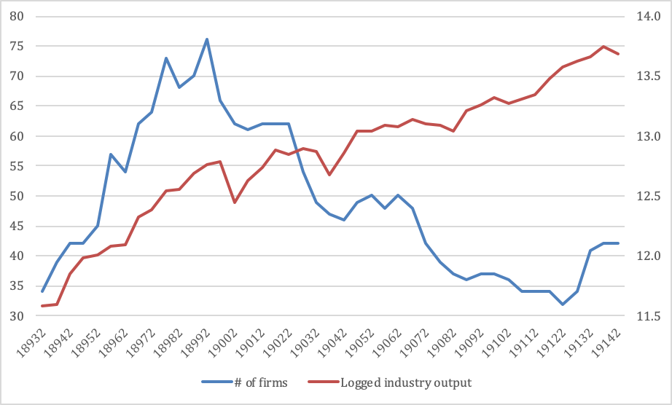

Table A3. Imports, production, and exports, 1880-1900 (units: kori=0.18 ton)
Year | Imports from: |  | Total | Dom. production | Export | Dom. supply
 | England | India
1880 | 84,367 | 10,908 | 95,324 |  |  | 95,324
1881 | 73,515 | 17,932 | 92,421 |  |  | 92,421
1882 | 61,708 | 21,794 | 84,324 |  |  | 84,324
1883 | 55,687 | 26,448 | 82,135 | 2,326 |  | 84,461
1884 | 48,790 | 21,797 | 70,622 | 5,687 |  | 76,309
1885 | 40,437 | 30,887 | 71,324 | 3,370 |  | 74,694
1886 | 45,251 | 36,850 | 82,101 | 16,217 |  | 98,318
1887 | 54,103 | 56,884 | 111,096 | 25,273 |  | 136,369
1888 | 77,583 | 80,546 | 158,281 | 33,142 |  | 191,423
1889 | 62,194 | 80,488 | 142,929 | 69,959 |  | 212,888
1890 | 59,703 | 46,566 | 106,588 | 108,374 | 31 | 214,931
1891 | 42,624 | 15,560 | 58,123 | 160,207 | 108 | 218,222
1892 | 53,494 | 27,527 | 81,534 | 213,489 | 109 | 294,914
1893 | 48,426 | 16,216 | 65,174 | 222,223 | 1,053 | 286,344
1894 | 45,353 | 7,778 | 53,555 | 304,584 | 11,796 | 346,343
1895 | 44,157 | 4,472 | 49,876 | 383,565 | 11,776 | 421,665
1896 | 63,859 | 2,854 | 67,373 | 428,864 | 41,916 | 454,321
1897 | 52,380 | 355 | 54,555 | 544,461 | 140,116 | 458,900
1898 | 52,697 | 353 | 54,563 | 670,067 | 229,445 | 495,185
1899 | 27,101 | 252 | 28,339 | 785,612 | 341,202 | 472,749
1900 | 30,035 | 101 | 30,941 | 647,484 | 208,732 | 469,693
Source: Takamura (1971), Vol. 1, pp. 146, 183; Association data (dom. production in 1883-85).
Table A4. Imports and domestic production by variety 1891-93 (units: kori=0.18 ton)
Imports from: | Variety (count) | 1891 | 1892 | 1893
India | 10’s-18’s | 2,449 | 4,507 | 1,164
India | 20’s | 17,570 | 17,657 | 12,376
India | Subtotal | 20,019 | 22,164 | 13,540
England | 16’s-24’s | 13,079 | 13,130 | 9,385
England | 28’s-32’s | 13,727 | 14,967 | 8,737
England | 38’s-42’s | 1,431 | 2,345 | 1,759
England | 32’s doubled | 2,506 | 10,827 | 12,045
England | 42’s doubled | 5,882 | 10,827 | 12,045
England | 60’s-120’s gassed | 5,377 | 7,809 | 8,532
England | Subtotal | 42,003 | 48,444 | 40,458
Total |  | 62,022 | 70,608 | 53,998
(Total import, stat.) |  | 58,123 | 81,534 | 65,174
Domestic production | <14’s |  | 43,677 | 43,052
Domestic production | 14’s-15’s |  | 38,064 | 39,579
Domestic production | 16’s |  | 36,347 | 44,125
Domestic production | 17’s-19’s |  | 8,918 | 10,617
Domestic production | 20’s |  | 49,919 | 68,604
Domestic production | 21’s-24’s |  | 1,390 | 3,894
Domestic production | 25’s-27’s |  | 104 | 31
Domestic production | 28’s-32’s |  | 4,329 | 8,121
Domestic production | 33’s-37’s |  | 113 | 131
Domestic production | 38’s-42’s |  | 51 | 0.2
Domestic production | Other |  | 8,377 | 6,730
Domestic production | Total | 160,207 | 189,206 | 225,091
Source: Takamura (1971), Vol. 1, p. 184. Per source, import data come from port statistics in Kobe and Tokyo, therefore, does not correspond exactly to customs statistics data in Table 1 but captures most of it.

Table A5. Imports and domestic production by variety, 1898 (units: kori=0.18 ton)
Variety | Estimated import |  | Dom. production | Export | Domestic supply
 | min | max |  |  | min | max
<16’s |  |  | 160,355 | 3,246 | 157,109 | 157,109
16’s-24’s | 4,248 | 4,248 | 453,936 | 198,246 | 259,938 | 259,938
16’s |  |  | 224,982 | 120,039 | 104,943 | 104,943
20’s |  |  | 208,479 | 77,905 | 130,574 | 130,574
28’s-32’s | 3,186 | 3,186 | 22,032 | 45 | 25,173 | 25,173
38’s-42’s | 531 | 531 | 2,115 |  | 2,646 | 2,646
60’s gassed | 6,372 | 7,434 | 19 |  | 6,391 | 7,453
80’s gassed | 9,558 | 10,620 | 3,044 |  | 12,602 | 13,664
100’s gassed | 2,655 | 2,655 |  |  | 2,655 | 2,655
120’s gassed | 1,593 | 1,593 |  |  | 1,593 | 1,593
doubled <32’s |  |  | 517 |  | 517 | 517
32’s doubled | 7,965 | 9,558 | 1,779 |  | 9,744 | 11,337
42’s doubled | 14,337 | 15,930 | 7,022 |  | 21,359 | 22,952
Total | 50,445 | 55,755 | 650,819 | 201,537 | 499,727 | 505,037
Source: Takamura (1971), Vol. 1, p. 322.

A.3 Industry Association-mandated output cuts
Table A6 presents the details of Boren-mandated output cuts and (in the right column) our measure of their relative impact on low-end products. For output cuts imposed as mandated holidays, we converted those into percentage terms by dividing the number of holidays by 30 (e.g., 4/30=0.133). The numbers in the column “Implied fraction of lower counts mandated cuts” is the difference between the numbers in previous two columns.

Table A6. Mandatory output cuts during our sample period
 |  | Output of 20 count and lower | Output of 21 count and higher | Implied relative fraction of lower counts mandated cuts
year | month | Policy detail |  | Implied relative fraction of lower counts mandated cuts
1899 | 1 | 4 mandated holidays | 4 mandated holidays | 0
1899 | 2-12 | None | None | 0
1900 | 1-4 | None | None | 0
1900 | 5-7 | 4 mandated holidays | None | 0.133
1900 | 8-12 | 40% of spindles to be idled or suspension of night shift | None | 0.400
1901 | 1-3 | 40% of spindles to be idled or suspension of night shift | None | 0.400
1901 | 4-12 | None | None | 0
1902 | 1-6 | None | None | 0
1902 | 7-12 | 4 mandated holidays | None | 0.133
1903 | 1-12 | None | None | 0
1904 | 1-12 | None | None | 0
1905 | 1-12 | None | None | 0
1906 | 1-12 | None | None | 0
1907 | 1-12 | None | None | 0
1908 | 1-4 | 5 mandated holidays | None | 0.167
1908 | 5-12 | 27.5% of spindles to be idled or suspension of night shift | None | 0.275
1909 | 1-12 | 27.5% of spindles to be idled or suspension of night shift | None | 0.275
1910 | 1-4 | 20% of spindles to be idled or suspension of night shift | None | 0.200
1910 | 5-9 | None | None | 0
1910 | 10-12 | 27.5% of spindles to be idled; or 12.5% of spindles to be idled, plus 4 days and 2 hours per workday mandated holidays | 20% of spindles to be idled or 5 days and 2 hours per workday mandated holidays | 0.075
1911 | 1-9 | 27.5% of spindles to be idled; or 12.5% of spindles to be idled, plus 4 days and 2 hours per workday mandated holidays | 20% of spindles to be idled or 5 days and 2 hours per workday mandated holidays | 0.075
1911 | 10-12 | 27.5% of spindles to be idled; or 12.5% of spindles to be idled, plus 4 days and 2 hours per workday mandated holidays | 10% of spindles to be idled or 5 days mandated holidays | 0.175
1912 | 1-3 | 27.5% of spindles to be idled; or 12.5% of spindles to be idled, plus 4 days and 2 hours per workday mandated holidays | 10% of spindles to be idled or 5 days mandated holidays | 0.175
1912 | 6-9 | 4 mandated holidays | 4 mandated holidays | 0
1912 | 10-12 | None | None | 0
1913 | 1-12 | None | None | 0
1914 | 1-11 | None | None | 0
Source: compiled from Shoji, Otokichi, 1930. Boseki Sogyo Tanshuku Shi (History of Operational Curtailments in Cotton Spinning, in Japanese). Nihon Mengyo Kurabu, Osaka, Japan.

Since in the main text we use semi-annual data in our IV growth regression estimations, we converted the numbers from Table A6 into semi-annual data by multiplying the implied relative fraction of lower counts mandated output cuts by the number of months during which the restrictions were applied in any given semi-annual period, divided by 6. For example, 4 mandated holidays in the first half of 1900 were imposed for two months (May and June), hence our measure of mandatory output cuts impact on lower counts for the first half of 1900 is 0.133*2/6 = 0.089. For the second half of the same year it is 0.133*1/6 (July output cuts) + 0.4*5/6 (output cuts in the rest of the year) = 0.356, and so on.

A.4 Initial scale of new product introduction and definitions of product experimentation
Figure A2 presents the distribution of within-firm shares of newly introduced products. The mean and median within-firm shares are 5.27 percent and 1.39 percent, respectively. The majority of new products in our data are thus introduced as a small share of firm’s total output, and new product introduction below three percent threshold are quite common. However, this initial small scale of new product introduction is much more pronounced among firms with high-end machines than for firms without such machines (the mean and median within-firm shares of newly introduced products for the first time for firms with high-end machines are 3.49 percent and 0.9 percent respectively, as opposed to 5.74 percent and 1.58 percent, respectively, for firms with no high-end machines).

Figure A2. Distribution of within-firm share of newly introduced products
mean | s.d. | 10th | 25th | 50th | 75th | 90th | N
5.27 | 10.43 | 0.08 | 0.33 | 1.39 | 4.91 | 15.21 | 793

While in the main text we have used the three-percent cutoff of the within-firm share of newly introduced products as our empirical definition of an experimental product, we conducted sensitivity analysis and confirmed that the findings are robust to using reasonable alternative thresholds (such as two percent or four percent). It is also possible to define experiments in alternative ways. For example, we may consider a newly introduced product to be experimental if it was discontinued (at least for a certain period of time) after being introduced. Since firms may not know which product varieties are going to be continued and which are going to be discontinued at the time of their introduction, defining experimental product varieties in this way gives rise to a “selection on outcome” concern. We did try such alternative definitions anyway, and confirmed that our basic results still continue to hold. Details are available upon request.
A.5 Concentration of output, high-end machines, and product varieties
Table A7. Concentration of output, high-end machines, high-end and low-end products
 | High-end machine capacity
Output quintile | 1893 | 1899 | 1907 | 1913
1 | - | 486 | 256 | 144
2 | - | 2,816 | 1,799 | 866
3 | - | 2,322 | 5,313 | 12,469
4 | 5,445 | 3,087 | 4,351 | 47,190
5 | 2,966 | 16,314 | 67,100 | 122,159
 | Number of high-end product varieties
Output quintile | 1893 | 1899 | 1907 | 1913
1 | 0.0 | 0.5 | 0.4 | 0.3
2 | 0.1 | 1.1 | 0.8 | 0.3
3 | 0.3 | 0.6 | 0.9 | 1.9
4 | 1.1 | 0.1 | 1.2 | 3.0
5 | 1.1 | 1.3 | 3.3 | 6.5
 | Number of low-end product varieties
Output quintile | 1893 | 1899 | 1907 | 1913
1 | 2.3 | 1.8 | 1.8 | 2.3
2 | 2.7 | 3.4 | 2.9 | 2.7
3 | 4.1 | 4.1 | 2.9 | 3.7
4 | 4.6 | 3.8 | 5.4 | 5.0
5 | 6.2 | 5.6 | 5.4 | 9.2
Source: Our calculations using the data described in the main text and in the appendix.

Table A7 presents high-end machine capacity (measured by the number of high-end machines spindles installed), the number of high-end product varieties and the number of low-end product varieties by quintiles of total output (firm size measured by output scale, as in the right panel of Figure 3) at four points in time during our sample. The top panel shows that as high-end machine capacity increases from virtually zero at the start of our sample, it spreads out across firms of different size, but remains heavily concentrated among the largest firms (even though the composition of the largest firms changes due to higher growth rates of firms with high-end machines, as we document below). Not surprisingly perhaps, we can see the same pattern in the number of high-end product varieties produced in the middle panel. What is most interesting, however, is that the number of low-end product varieties (which do not require high-end machines for their production) also becomes heavily concentrated over time, especially in the last period (which corresponds to the second subperiod in Table 2 in the main text when there was a big increase in within-firm number of product varieties). When the top decile firms (in terms of output) are compared with the second decile firms in 1913 (not shown), both categories are similar in the number of high-end product varieties and high-end machine capacity, but the number of low-end product varieties in the former category is twice as many as that in the latter category. This difference corresponds to the difference in total output, indicating that the expansion of low-end product varieties is also critical for firm growth.
Table A8 presents the average numbers of all product varieties and of low-end product varieties among those, produced by firms that did and did not have high-end machines at a given point in time. We present these statistics for the whole sample as well as for two subperiods in Table 2 in the main text. Firms with high-end machines produced on average almost twice as many product varieties as firms that did not have such machines over the whole period, with the gap larger in the second period than in the first (all the differences in means in Table A8 are statistically highly significant). Even more interestingly, firms that had high-end machines produced more low-end product varieties compared to firms that only had low-end machines, and the gap, once again, is larger in the second subperiod than it is in the first. When limited to firms that had high-end capacity above the mean of 36,000 spindles (14 out of 42 firms that had high-end machines), the gap with firms with no high-end machines is even much larger.

Table A8. Number of products and low-end products by firms with and without high-end machines
 |  | Firms with high-end machines |  |  | Of which: firms above the mean # of spindles in high-end machines | Firms with no high-end machines
 |  | 1893.2-1914.2 | 1893.2-1906.2 | 1907.1-1914.2 | 1893.2-1914.2 | 1893.2-1914.2 | 1893.2-1906.2 | 1907.1-1914.2
Number of products | Mean | 7.75 | 6.77 | 9.52 | 11.01 | 3.98 | 3.89 | 4.29
Number of products | St. Err. | 0.19 | 0.18 | 0.42 | 0.46 | 0.07 | 0.07 | 0.17
Number of products | # obs | 725 | 465 | 260 | 205 | 1031 | 810 | 221
Number of low-end products | Mean | 4.94 | 4.59 | 5.57 | 6.00 | 3.77 | 3.71 | 3.99
Number of low-end products | St. Err. | 0.13 | 0.14 | 0.27 | 0.34 | 0.06 | 0.06 | 0.16
Number of low-end products | # obs | 725 | 465 | 260 | 205 | 1031 | 810 | 221
Source: Our calculations using the data described in the main text and in the appendix. The difference in means between firms with and without high-end machines are highly statistically significant using double-sided t-test.

A.6 Selection into high-end machine adoption
We have taken the separation of firms into those that adopt high-end machines with the aim of conducting product innovation and subsequent product diversification and firms that stick to scaling their existing products (or do not grow at all) as given. Here, we use our data to try to open the “black box” of this separation.
We first conduct a simple cross-sectional comparison of founding team characteristics between firms that installed high-end machines at some point during our sample (including those that entered with high-end machines right away) and firms that never had high-end machines. Since university educated engineers played a crucial role at all stages of utilizing high-end machines and firm growth, we test whether firms that managed to secure the services of such engineers at the time of their founding (incorporation) were more likely to have high-end machines. We also test whether market ties, proxied by the presence of merchants among members of founding teams, played an independent role in high-end machine adoption. The results of estimating the effects of these two founding team characteristics are presented in columns (1) and (3) of Table A9. In column (1) the dependent variable is the firm-specific dummy equal to one if the firm had high-end machines at some point during our sample and zero otherwise, while in column (3), where the sample is limited to post-1893 entrants, it is the dummy equal to one if the firm entered with high-end machines and zero otherwise (pre-1893 entrants basically did not have a chance to install high-end machines at the time of entry).
The estimation results show that firms which installed high-end machines were indeed much more likely to employ a university educated engineer already at the time they were founded (note that no firm employed more than one at the time they were founded). The presence of merchants on the founding teams is also positively associated with high-end machines, but the magnitude of the coefficient is much smaller and it is statistically not significant at conventional levels. Historical evidence documented in Kinugawa (1964), company histories and other sources shows that it was both (i) forward-looking firms realizing that they needed to secure high-level engineering human capital if they wanted to install high-end machines and try to adopt new, unfamiliar production technologies required to operate at the high end of the product space; and (ii) hired educated engineers playing a key role in working with the British suppliers to order, customize, and install high-end machines. Thus, while we cannot claim “causality” whereby having university educated engineers at founding led to adoption of high-end machines, we do see strong selection (positive assortative matching) on both sides (founding teams and engineers), associated with the adoption of high-end machines.
To probe for this assortative matching further, we add firm size (measured by the number of spindles installed) at the time of entry as another regressor. Initial entry size has been shown to be associated with the entrepreneurial ability both theoretically (Lucas, 1978) and empirically (Klepper, 2010), so we use it as a proxy for entrepreneurial ability of the founding team in our data. Estimation results presented in columns (2) and (4) of Table A9 show that higher entry size in our data is indeed positively and statistically highly significantly associated with the adoption of high-end machines. However, while whatever impact the presence of merchants had on high-end machines adoption is almost completely absorbed by entry size, the coefficients on university educated engineers employed at founding, although smaller in magnitude, remain economically and statistically significant. Indeed, comparing the magnitudes of the coefficients on engineers and entry size, we can see that having a university-educated engineer has an estimated association with high-end machines adoption which is equivalent to an increase in more that 10,000 spindles (more than one standard deviation from the mean) in entry size. Thus, hiring university-educated engineers’ human capital can be seen to be a critically important independent factor in high-end machine adoption, alongside higher entry size.

Table A9. Founding Team Differences Among Firms with and without High-End Machines
DV: | Probability of ever having high-end machines |  | Probability of entry with high-end machines
VARIABLES | (1) | (2) | (3) | (4)
University educated engineer employed at founding | 0.333*** | 0.241** | 0.313** | 0.230*
University educated engineer employed at founding | (0.111) | (0.109) | (0.132) | (0.125)
Merchant a member of founding team | 0.071 | 0.018 | 0.064 | 0.024
Merchant a member of founding team | (0.094) | (0.090) | (0.100) | (0.093)
Firm capacity (in thousands of spindles) at entry |  | 0.019*** |  | 0.018***
Firm capacity (in thousands of spindles) at entry |  | (0.005) |  | (0.005)
Constant | 0.287*** | 0.170** | 0.144* | -0.003
Constant | (0.069) | (0.074) | (0.073) | (0.080)
Observations (firms) | 105 | 105 | 69 | 69
R-squared | 0.093 | 0.191 | 0.091 | 0.231
Linear probability estimation. Standard errors in parentheses. *** p<0.01, ** p<0.05, * p<0.1The sample in columns (3) and (4) is limited to post-1893 entrants. Probit estimations lead to very similar results.

We next utilize observations on firms which we observe while they did not yet have high-end machines they would have in the future. Among the 42 firms that had high-end machines at some point during our sample, 19 entered with high-end machines right from the beginning but 23 installed them at some point after entry. Four of these 23 added their first high-end machines prior to the start of product variety data, so we do not get a chance to observe them before that. For the remaining 19 firms we do have this opportunity, and we use this sample to look into the issue of “pre-treatment” selection by comparing those firms before they actually adopted high-end machines with the firms that never introduced such machines during our sample. If the “treatment” (adoption of high-end machines) was an outcome of a random draw, we should not observe systematic differences in the pre-treatment period.
In Panel A of Table A10 we present the results of the estimations, where the dependent variable is a dummy equal to one if the firm adopted high-end machines in the future and zero otherwise. We regress this on various actions and characteristics before they had high-end machines (if any). To err on the side of caution, we exclude not only observations after the high-end machines appear on firms’ balance sheets but also all observations pertaining to the period after firms placed their first high-end machines order (if any), even though the machines are not reflected in the balance sheets yet. While this results in losing observations (including all observations on three of the 19 firms whose orders were placed early), it makes sure that, especially when looking at experimental production, we do not inadvertently pick up experiments conducted with high-end machines that may have been partially installed.
The estimation results in column (1) in Panel A of Table A10 show that firms that ordered high-end machines in the future (hereafter, “future adopters,” for short) tended to introduce significantly more new products on experimental basis than firms that never adopted high-end machines, already prior to adoption. Strikingly, they were even more likely to conduct product upgrading experiments than diversification experiments compared to other firms during the pre- adoption stage. Although, as mentioned, producing most high-end products was impossible without high-end machines, stretching low-end machines enabled some small-scale production at the (lower end of the) high-end product space, and this is what we apparently observe in these data. Thus, one interpretation of these results is that potential entrepreneurial firms were conducting small pre-adoption experiments to determine whether they should make the costly decision of investing in high-end machines (Kerr et al., 2014).
According to the model in McCardle (1985), experiments with new technologies result in a separating equilibrium where some firms (receiving bad signals) decide not to adopt the new technology, while other firms (receiving good signals) decide to go ahead with investment. We test this in another regression, the results of estimating which are presented in Panel B of Table A10. In column (1) we calculate the fraction of successful experiments (products first introduced on experimental basis and subsequently scaled) among all experiments started by firms at time t and we use it as a key explanatory variable in a regression where the dependent variable is, once again, the dummy equal to one if the firm was a future adopter and zero otherwise. Because we are conditioning on starting at least one experiment at t, the number of observations is much smaller than in Panel A. Nevertheless, there is an economically important and statistically significant at the 10 percent level relationship between success in experimental production and future high-end machine adoption––the standard deviation from the mean in this sample is 0.44, so one standard deviation from the mean success rate is estimated to increase the probability of high-end machine adoption in the future by about 8 percentage points, or by about 40 percent, given that the mean fraction of future high-end machines adoption in the sample is 0.2. Thus, future adopters both conducted more experiments than non-adopters and were more successful in the experiments they did conduct, in line with the predictions in McCardle (1985).
In columns (2) and (3) of Panel B in Table A10 we look at how the duration of successful and failed experiments, respectively, was different between future adopters and non-adopters. As can be seen from the corresponding coefficients, in the case of successful experiments, those conducted by future adopters were significantly shorter than those conducted by non-adopters, but the opposite is true of eventually failed experiments. The first finding is consistent with future adopters having better success odds (higher exponential arrival rate of success in any given experiment). The latter finding renders itself to several possible interpretations, the most likely ones (not necessarily mutually exclusive) being (a) extra confidence future adopters had about their chances to eventually succeed which made them persist longer despite a string of bad signals, and (b) higher value placed by future adopters on experiments as a means of accumulating technological and marketing knowledge, even regardless of outcome.
In column (2) of Panel A in Table A10 we add more regressors capturing time-varying firm characteristics––employment of university educated engineers, market ties (proxied by merchants as board members), the situation in top management teams (TMT), expansion of (low-end) machine capacity, as well as output scale and scope. The coefficient on upgrading experiments is reduced in magnitude but remains economically and statistically highly significant in predicting which firms are going to order high-end machines in the future. Among other variables, market ties (as captured by the presence of merchants on boards) significantly positively affect the probability of adding high-end machines in the future in this sample, but the number of university educated engineers employed has no such impact. Thus, even though having a university-educated engineer at the time of founding is an important predictor of high-end machines at entry or at some point in the future (see Table A11 above), firms that did not adopt high-end machines at the time of entry did not on average employ more educated engineers than other firms either, until they decided to order such machines for the first time or even later.

Table A10. “Selection” Among Firms with no High-End Machines
Panel A. Characteristics and actions associated with future high-end machine orders
 | DV: Dummy equal to 1 if placed high-end machines orders in the future
VARIABLES | (1) | (2)
Number of upgrade experiments started at t | 0.418*** | 0.350***
Number of upgrade experiments started at t | (0.147) | (0.119)
Number of diversification experiments started at t | 0.066** | 0.031
Number of diversification experiments started at t | (0.031) | (0.038)
Firm age | -0.003 | 0.006
Firm age | (0.008) | (0.009)
Number of university-educated engineers employed at t |  | -0.073
Number of university-educated engineers employed at t |  | (0.057)
Dummy equal to one if merchant a board member at t |  | 0.167**
Dummy equal to one if merchant a board member at t |  | (0.079)
Shared TMT leadership at t |  | 0.003
Shared TMT leadership at t |  | (0.096)
Dummy equal to one if a TMT leader ousted in the previous two years |  | -0.169***
 |  | (0.063)
Dummy equal to one if added low-end machines at t |  | -0.044
Dummy equal to one if added low-end machines at t |  | (0.042)
Logged firm total output at t |  | 0.111**
Logged firm total output at t |  | (0.047)
Logged number of products at t |  | -0.014
Logged number of products at t |  | (0.058)
Constant | 0.211** | -0.734**
Constant | (0.080) | (0.361)
Semiannual time dummies | Included | Included
Observations | 964 | 921
R-squared | 0.065 | 0.212
Pooled OLS. Robust standard errors clustered at the firm level in parentheses. *** p<0.01, ** p<0.05, * p<0.1. Sample limited to firms before high-end machine orders were placed for the first time.

Panel B. Success rates and duration of successful and unsuccessful experimental production
 | DV: Dummy equal to 1 if placed high-end machines orders in the future
VARIABLES | (1) | (2) | (3)
Fraction of successful experiments among those started at t | 0.208*
Fraction of successful experiments among those started at t | (0.117)
Average duration of successful experiments |  | -0.037**
Average duration of successful experiments |  | (0.015)
Average duration of failed experiments |  |  | 0.043***
Average duration of failed experiments |  |  | (0.010)
Firm age | 0.008 | 0.025 | -0.000
Firm age | (0.006) | (0.016) | (0.006)
Constant | 0.201*** | 0.266** | 0.203***
Constant | (0.070) | (0.128) | (0.064)
Semiannual time dummies | Included | Included | Included
Observations | 153 | 98 | 172
R-squared | 0.294 | 0.430 | 0.335
Pooled OLS. Robust standard errors in parentheses. *** p<0.01, ** p<0.05, * p<0.1.
Looking at the top management teams (TMT), Agarwal et al. (2019) find that stable shared leadership (that is, having multiple TMT leaders who created division of labor while avoiding rifts leading to forced departures) contributed to firm growth and ability to attract engineering talent. We test this here by including also dummies capturing whether a firm had shared TMT leadership and whether there was a forced TMT leader departure in the two years preceding time t (where “forced” is defined as not due to death, illness, or resignation for personal circumstances unrelated to the firm). While shared TMT leadership by itself does not predict future adoption of high-end machines, we do find that within-TMT conflicts leading to forced departures are strongly negatively associated with high-end machines adoption. Since such departures represent disruptions and loss of managerial human capital, this finding is in line with the conclusions drawn in Choi, et al. (2019) using U.S. Census data. Finally, we also see that while future adopters were somewhat larger in terms of their output scale, they were neither more diversified nor more likely to expand their (low-end) machine capacity than other firms prior to adopting high-end machines. Thus, we have another strong piece of evidence showing that diversification and expansion of low-end machines happened after firms adopted high-end machines and successfully expanded into the high-end product space, not before.
To conclude, it appears that (a) conducting more experiments and being more successful in those experiments; (b) stronger market ties (merchants as members of boards); and (c) ability to avoid within-TMT conflicts leading to forced departures and loss of human capital were all salient features associated with “selection into treatment” (future high-end machine adoption). At the same time, most of the impact on growth, product varieties proliferation and hiring of educated engineers (as well as further increase in experimental production) happened already after high-end machines had been adopted and the firms had embarked on the process of growth using those machines and exploiting the complementarity channel from product upgrading to product diversification.

A.7 Flexible production system
According to our interviews with Kanji Tamagawa (a prominent Japanese historian of cotton spinning technology), switching the direction of twist (from S to Z and vice versa) and/or changing the count to be spun between adjacent counts (say, from 16 to 18 or from 20 to 22) involved the following operations:

Operation | Required time
- Changing the draft (adjusting the draft change gear) | About 10 minutes
- Changing the twist number (adjusting the twist change gear) | About 10 minutes
- Changing the direction of the twist (changing the direction of the tin roller) | About 10 minutes
- Changing the spindles rotation speed (adjusting the gear) | About 10 minutes
- Changing the traveler (choosing a traveler of appropriate weight) | About 30 minutes

With appropriate skill, the first four operations could be completed during the time required to complete the fifth, so, under ideal conditions, the whole process would take about 30 minutes.
However, if the task was to change to a count of yarn that was further apart (such as from 16 count to 20 or from 24 count to 32 count), such a change also required a change in roving to be fed into the machine, taking about two hours, so such adjustment was much costlier. Thus, firms with a more diversified product portfolio could change counts more easily.

Figure A4. Historical trend in the fraction of non-S twist products in the total number of product varieties

A.8 Low-end product quality

Table A11. Comparing 20-count Prices and Female Operative Wages Dispersion
 | Coefficient of variation | Quartile coefficient of dispersion | 90-10 percentile coefficient of dispersion
Prices of 20 count | 0.028 | 0.016 | 0.031
Wages of female operatives | 0.147 | 0.094 | 0.182

Note: The coefficient of variation is the ratio of the mean over the standard deviation. The quartile coefficient of dispersion is (p75-p25)/(p75+p25). The 90-10 percentile coefficient of dispersion is (p90-p10)/(p90+p10). Averages for the whole sample.

Table A12. OLS Regression of Logged Market Share of 20 Count on Logged 20-count Price
 | DV: Logged market share of 20 count
Estimation | OLS
Logged 20-count price | -3.056**
Logged 20-count price | (1.191)
Number of across-count portfolio rebalancing (between 17-48 counts) | -0.097***
 | (0.030)
Constant | 2.851**
Constant | (1.423)
Semiannual time dummies and firm dummies | Included
Observations | 721
R-squared | 0.618
Robust standard errors in parentheses. *** p<0.01, ** p<0.05, * p<0.1.

Figure A5. Estimated Quality Index and Historical Quality Ratings

Note: Quality rating is firm-level quality ratings of Z-twist 20 count in 1907 determined by the cotton yarn quality rating committee at the Osaka Three Articles Exchange (Arao, 1920, pp. 33-36). Rating 4 indicates the highest quality and rating 1 indicates the lowest quality. “Quality index IV” represents averages of our estimated quality measures for the same firms over the period of 1906-1909.

A.9 Market competition
Figure A6. Fraction of Firms, Output ratio, and Price

References cited in the appendix, not included in the references list in the main text
Arao, Yoshimichi, 1920. Menshi Boseki oyobi Menshi Torihiki (Cotton spinning and cotton yarn transactions, in Japanese). Kogyo Kyoikukai Shuppanbu, Osaka.
Agarwal, Rajshree, Serguey Braguinsky, and Atsushi Ohyama, 2019. “Centers of Gravity: The Effect of Stable Shared Leadership in Top Management Teams on Firm Growth and Industry Evolution.” Strategic Management Journal, https://doi.org/10.1002/smj.3048.
Choi, Joonkyu, Nathan Godlsclag, John Haltiwanger, and J. Daniel Kim, 2019. “The Post Entry Growth and Survival of Business Startups: The Role of Founding Teams.” Unpublished.
Fuji Boseki. 1998. Fuji Boseki Hyakunenshi (100 years of Fuji Boseki, in Japanese), Fuji Boseki, Tokyo.
Gakushikai, 1886-1914. Gakushikai Kaiinroku (The Alumni List of University Graduates’ Society, in Japanese). Tokyo (restricted use, only for members).
Jinmeiroku, 1892, 1898, 1907. Nihon Zenkoku Shoko Jinmeiroku (All-Japan Registry of Traders and Craftsmen, in Japanese). Available at http://dl.ndl.go.jp/search/searchResult?featureCode=all&searchWord=日本全国商工人名録&viewRestricted=0.
Kanebo. 1988. Kanebo Hakunen-shi [100 Years of Kanebo, in Japanese]. Kanebo Kabushiki Gaisha, Osaka.
Klepper, Steven, 2010. “The Origin and Growth of Industry Clusters: The Making of Silicon Valley and Detroit.” Journal of Urban Eonomics, 67: 15-32.
Kokajo (Company reports) (1883-1914), Osaka University Library: Osaka, Japan, in Japanese.
Kumamoto Koto Kogyo Gakko, 1901-1914. Kumamoto Koto Kogyo Gakko Ichiran (Catalog of Kumamoto Technical college, in Japanese).
Kurabo, 1953. Kaiko Rokujugonen (Looking Back at 65 years, in Japanese). Osaka, Kurashiki Boseki Kabushiki Gaisha.
Kyoto Koto Kogei Gakko, 1905-1914. Kyoto Koto Kogei Gakko Ichiran (Catalog of Kyoto High School of Technology and Craftsmanship, in Japanese).
Lucas, Robert E. Jr., 1978. “On the Size Distribution of Firms.” Bell Journal of Economics
McCardle, Kevin F., 1985. “Information Acquisition and the Adoption of New Technology.” Management Science, 31(11): 1372-1389.
Nagoya Koto Kogyo Gakko, 1908-1914. Nagoya Koto Kogyo Gakkou Ichiran (Catalog of Hagoya Technical college, in Japanese).
Okamoto, Yukio. Chiho Boseki Kigyo-no Seiritsu-to Tenkai (Formation and Development of Cotton Spinning Firms in the Province, in Japanese), 1993. Kyushu Daigaku Shuppankai, Fukuoka.
Osaka Koto Kogyo Gakko, 1900-1914. Osaka Koto Kogyo Gakko Ichiran (Catalog of Osaka Technical college, in Japanese).
Osaka Sampin Torihikijo Seisan Jimusho, 1943. Sampin Shoshi (Brief History of Osaka Three Articles Exchange, in Japanese), Osaka, Japan.
Sendai Koto Kogyo Gakko, 1910-1914. Sendai Koto Kogyo Gakko Ichiran (Catalog of Sendai Technical college, in Japanese).
Shikibo, 1968. Shikishima Boseki Nanaju-gonenshi (Seventy five years of Shikishima Spinning, in Japanese), Osaka, Shikishima Boseki Kabushiki Gaisha.
Tokyo Koto Kogyo Gakko, 1886-1914. Tokyo Koto Kogyo Gakko Ichiran (Catalog of Tokyo Technical college, in Japanese).
Toyo Bōseki. 1986. Toyoboseki Hyakunenshi (One Hundred Years of Toyo Boseki). Toyobo (in Japanese): Osaka, Japan.
Unitika. 1989. Unitika Hyakunenshi (100 years of Unitika, in Japanese). Available at http://www.unitika.co.jp/company/archive/history/
Yakuinroku, 1893-1914. Zenkoku Shogaisha Yakuinroku (All-Japan Registry of Firms Executives, in Japanese). Available at http://dl.ndl.go.jp/search/searchResult?featureCode=all&searchWord=日本全国諸会社役員録&viewRestricted=0.

Braguinsky: University of Maryland, Robert H. Smith School of Business, Osaka University Institute of Economic and Social Research, and NBER, e-mail: sbraguinsky@rhsmith.umd.edu; Ohyama: Institute of Innovation Research, Hitotsubashi University, e-mail: ohyama@iir.hit-u.ac.jp; Okazaki: Tokyo University, Faculty of Economics, e-mail: okazaki@e.u-tokyo.ac.jp; Syverson: University of Chicago Booth School of Business and NBER, e-mail: chad.syverson@chicagobooth.edu.
We are grateful to Osaka University library and Prof. Takeshi Abe, its academic director at the time; to Yoshiyuki Murakami, head of the company history division of Toyo Boseki at the time (now retired); and to Kobe University Kanematsu Collection for their cooperation in allowing us to photocopy company reports used in this research.
Our newly collected and processed data, including photos of the originals, will shortly become publicly available from NBER Industry, Productivity, and Digitalization Data Library (http://www.nber.org/data).
A hand-written annotation (apparently by a Dobson & Barrow employee) reads that “This is a sample trial order so let everything be finished with the utmost care, as further large order depends on the same being satisfactory.” Amagasaki Spinning never placed another order with Dobson & Barrow, preferring to continue working with Platt Brothers. The note, however, gives a glimpse of the competition among British textile machinery makers.
As can be seen from the Amagasaki example above, one-two or even more years would normally elapse between the placing of the order and the time the machines would be fully installed and reflected in firms’ property inventories. (Newly arrived machines were commonly included in property inventories after they were installed and ready to be operated; prior to that, new arrivals would be reflected in balance sheets in the “expansion account” but not in property inventories, which are the primary source of our panel data on firm capacity.)
In addition to firm-by-firm acquisitions, there was one plant-by-firm acquisition, in which a firm bought just one of the plants from another firm. We know exactly which machines were involved in this acquisition too.
While, once again, we cannot claim causality based on our data, it is worth noting that in a recent paper, Choi et al. (2019) establish causal effect from founding team’s human capital to startup growth.
The results remain similar if we use all observations prior to high-end machines appearing on the balance sheets.

